|  |  |
| --- | --- |
| **What I did** | **What happened** |
| Ran same tests on original perftest (untouched). | VM 1:  Subscriber carrying on.  Figure 1  Publisher ended.  Figure 2  VM 2/3/4:  Publishers crashed with error.  Figure 3 |
| Run same tests on laptop. | Same outcome. Publisher 0 printed out results. Rest of publishers gave same error. |
| Change test by removing numSubscribers = 1 on publishers. Then running on laptop. | Same outcome as above. |
| Updated subscriber script to 100 bytes. | I realised subscriber had data length of 40KB while publisher were 100 bytes. |
| Reran tests with numSubscribers = 1 on laptop. | Same output. |
| Edited lines 1297/1298 in PerfTest.java adding the if statement discussed in meeting with Vlad. | Tests ran fine and files are in folder name “Edited Code”. |
| Updated to new version and ran tests. | As soon as I started the first publisher this appeared.  Figure 4 |
| Added -batchSize 0 to tests. | Test run fine. |

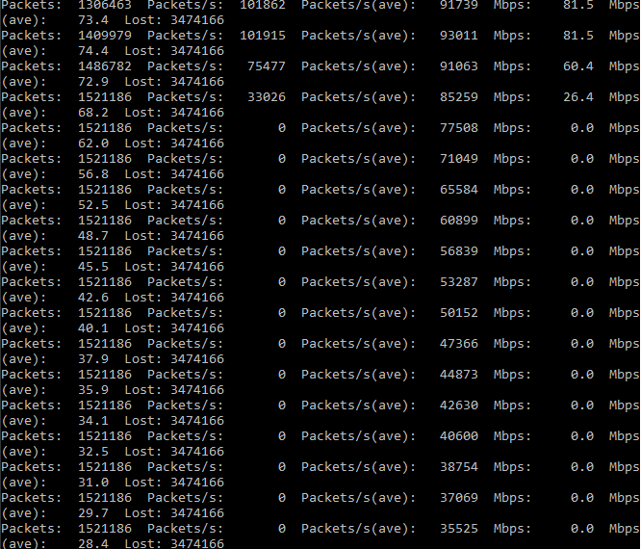

Figure 1

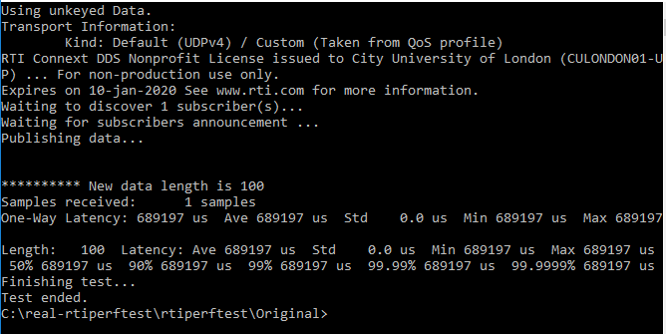

Figure 2

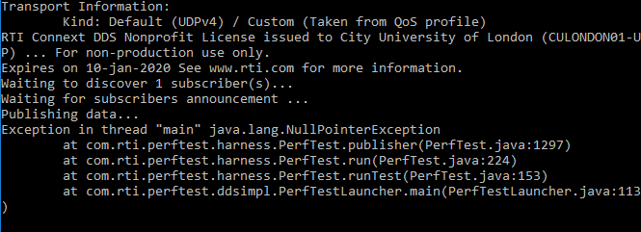

Figure 3

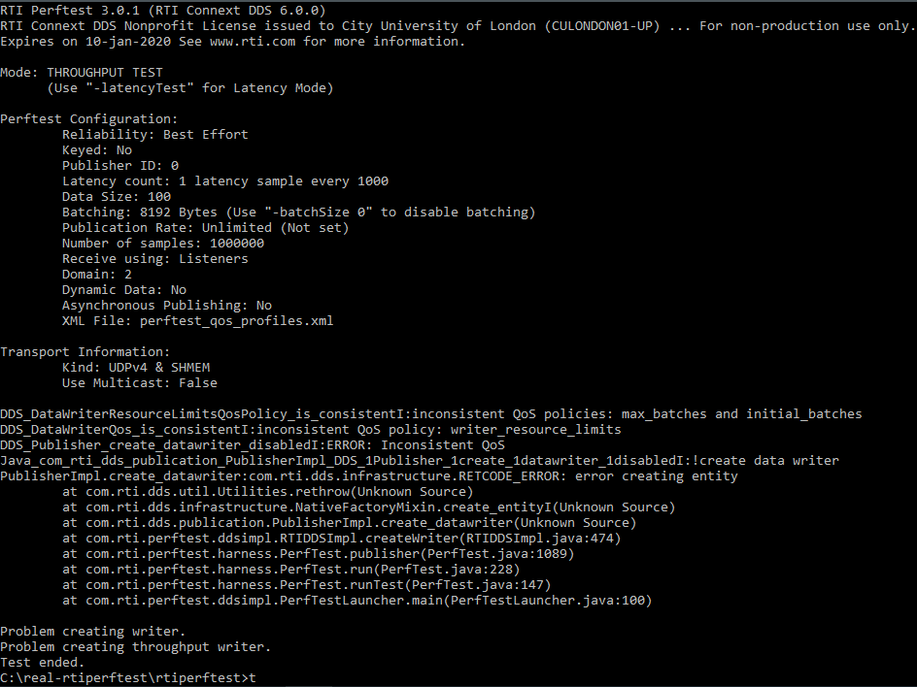

Figure 4